**User Scenarios**

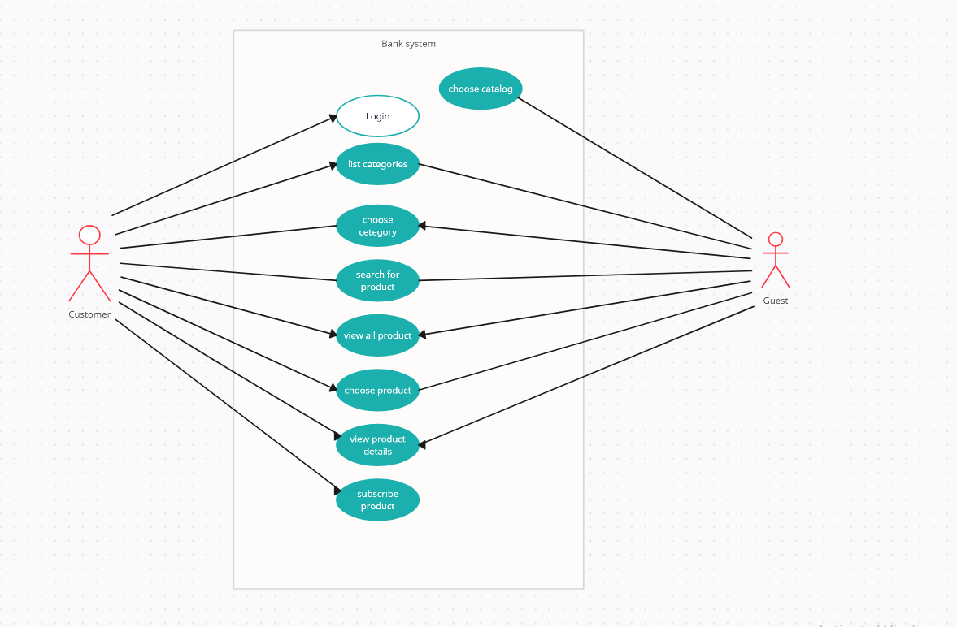

1. **Homepage**

**Title**: Open Homepage

**Primary actor:** visitor

**Goal:** The visitor wants to browse the website

**Main success scenario:**

* The guest views the website.
* The guest can choose either view the individual's product or the corporate products.
* The guest can login.

1. **Choosing Catalogue**

**Title:** Choose Catalogue

**Primary actor:** Guest

**Goal:** The guest wants to browse individual products or company products

**Pre-Conditions**: the user must be open home page

**Main success scenario:**

* Users can choose between browsing as individuals or as companies.
* Users can choose from three main categories: cards, accounts and certificates, and loans.
* Each category contains specific types of products.
* Users can explore the details of each product type within the selected category.

1. **bank's list of products**

**Title:** View the bank's list of products

**Primary Actor:** Individual or Corporate

**Goal:** As an individual or corporate you can view products like Cards, certificates & Accounts or **loans.**

**Main Success Scenario:**

* Individual or corporate navigates to the home page.
* Depending on the type of user, the web site will display products like Cards, certificates & Accounts or loans.

**Negative Scenario:**

* If Individual or Corporate need to buy any product, they must log in to apply for any product.

**Post-Conditions:**

* The Guest can see the list of products according to his choice) individuals or Corporates)

1. **bank's products**

**Title:** The bank's products

**Primary Actor:** Individuals and Corporates

**Goal:** Individuals and Corporates would like to explore one of these banking products (cards, loans, accounts and certificates)

**Main Success Scenario:**

1- Individuals and Corporates navigates to home page.

2-Depending on the type of user, the web site will display products (cards, loans, accounts and certificates)

3- Individuals and companies can explore all products in detail

**Negative Scenario:**

* If Individual or Corporate need to buy any product, they must log in to apply for any product.

**Post-Conditions:**

* The Guest can see all products (cards, loans, accounts and certificates) in detail.

1. **Customer Login**

**Title:** Login

**Primary Actor:** Customer

**Goal:** the customer wants to login to his account.

**Pre-Conditions:** the user must open the home page first then choose to log in.

**Main success scenario:**

* The user must enter a valid username and correct password.
* The password must has 8 characters contains letters and numbers and at least one uppercase and one special character.

**Post-Conditions:**

The user will be redirected to the listed category page

1. **Product Details**

**Title:**  Show product Details

**Primary Actor:** Individual or Corporate

**Goal**: As an individual or corporate he can view product details.

**Pre-conditions:**

* User must have access to this product based on his category.
* User can apply if only he is logged in.

**Main Success Scenario:**

* User must see what he is applying for, benefits and how to be qualified for it.
* Apply button to apply for product.

**Post-condition:** Navigate user to apply form or navigate up.

**Negative scenario:** If user apply without logging in a pop up should appear with message: you must log in to apply for this product.

1. **Apply for Account products**

**Title**: Apply for Account products

**Primary Actor:** Individual or Corporate

**Goal:**

1. As an individual he can apply for Current, Saving or Pay-roll Account.
2. As a corporate he can apply for Current Account.

**Preconditions:**

1. User must see only suitable options listed according to his actor / Category.
2. User must log in to apply for product.
3. User can view product and navigate to product details screen without logging in.
4. User must be qualified to open desired account.

**Main Success Scenario:**

1. User navigate to product form which contains product details and takes amount from user to open account. Then, show the yearly benefit rate for product and amount if exist.

2. A confirmation page must appear with all details.

1. After user confirms, pop up should appear with message: Account creation request has been sent for review you will receive SMS with confirmation in minutes on your phone.

**Post-condition:** Navigate user to category list page.

**Negative scenario:**

* If user apply without logging in a pop up should appear with message: "**you must log in to apply for this product".**
* If use cancel request on confirmation page a pop up should appear with message: "**you request has been cancelled".**
* If balance is not valid for request a pop up should appear with message:" I**nsufficient Balance"**.

1. **Cards product**

**Title:** Cards product

**Primary Actor:** Individual or Corporate

**Goal:**

* As an individual he can apply for (Prepaid card, Debit card, or Credit Card).
* As a corporate he can apply for (Prepaid card, Debit card, or Credit Card).

Preconditions:

1. User must see only suitable options listed according to his actor / Category.
2. User must log in to apply for product.
3. User must be qualified to open desired account.

**Main Success Scenario:**

1. User navigate to product form which contains product details and takes amount from user to open account. Then, show the yearly benefit rate for product and amount if exist.

2. A confirmation page must appear with all details.

3. After user confirms, pop up should appear with message: Card request has been sent for review you will receive SMS with confirmation in minutes on your phone.

1. Navigate user to category list page.

**Negative scenario:**

* If user apply without logging in a pop up should appear with message: you must log in to apply for this product.
* If user cancel request on confirmation page a pop up should appear with message: you request has been cancelled.
* If balance is not valid for request a pop up should appear with message: Insufficient Balance.

**Post-conditions:** The customer receives his card within the specified period.

1. **Certificate Product**

**Title:** Certificate Product

**Primary Actor:** Customer (individual or corporate)

**Goal:**

* A customer as an individual wants to apply for a 1-, 3- or 5-years certificate.
* A customer as a corporate wants to apply for a 3- or 5-years certificate.

**Preconditions:**

Customer must be logged in to their account. Customer must have a valid I-score. Customer must select the desired type of certificate that he wants to apply.

**Main Success Scenario:**

The customer navigates to the certificate products page. The system displays the selected type of certificate and its details. The customer confirms his subscription for the suitable certificate by clicking on “apply” button. The system notifies the customer by sending him a confirmation message on phone or email.

**Bad Scenario:**

* If the customer does not have a valid I-score so, he is not qualified for the desired certificate.
* If the customer does not log in his account so, he is not from our bank customers (guest mood) or he is our customer but, he forgot to log in.

**Admin Scenarios**

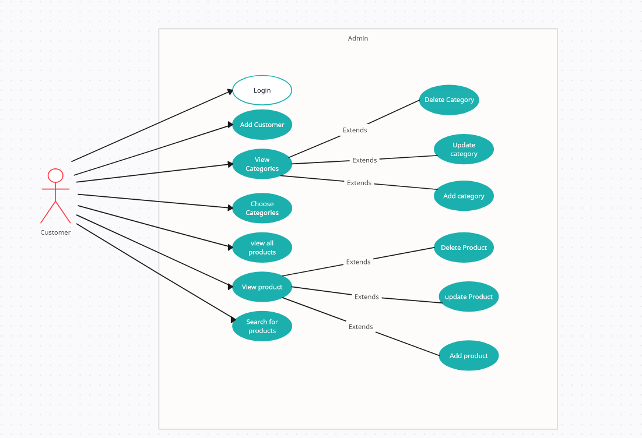

1. **Admin Login**

**Title:** login

**Primary actor:** admin

**Goal:** the admin will log in to his account

**Main Success Scenario:** the admin will enter a valid username and password

**Post-condition:** the admin will be redirected to listed category so he can create or delete or update in the categories or in the products

1. **Categories List.**

**Title:** Admin operations on categories.

**Primary Actor:** Admin.

**Goal:** Admin wants to add, update or delete category.

**Preconditions:**

* The Admin must be logged in to their accounts
* The Admin must be choose the categories section first.

**Main Success Scenario:**

The Admin after choosing categories section will see all categories and can do update, delete operations on each category or add a new one.

**Bad Scenario:**

Adding a category that already exists or the operation failed to be executed.

**Post-conditions:**

1-The new added category will be shown.

2-The deleted category will be removed.

3-The updated category data will be updated and shown.

1. **Product List Dashboard**

**Title:** Operations on product

**Access actor:** Admin

**Goals:** Admin makes Crud operation on The Products.

**Pre-conditions:** The Admin must be logged in to his account to have access to the dashboard

**Main Success Scenario:**

**1. Add product:**

- He will choose The Button "Add New Product" in the product list.

- Then, direct to the page "Add product" and then fill the forms with information.

- After that, click "add product".

2. **Update product:**

- He will choose The Button "update Product" in the product list (selected the product by id).

- Then, direct to the page "update product" that fills with product data selected and then update the data.

- After that, click "update product".

3. **Delete product:**

- He will choose The Button "delete Product" in the product list (selected the product by id).

- Then, he must confirm the delete operation.

- If yes, click "confirm delete".

- If want to take back on this step, click "cancel"

**Post condition:**

-The new product will be added in the product list and shown in the customer interface.

-The product data will be updated in the product list and also updated in the customer interface.

-The deleted product will be removed from the product list.

1. **Add Customer**

**Title:** add customer

**Primary actor:** admin

**Goal:** the admin create new account to customers

**Pre-condition:** the customers must have bank account to have an account in the website

**Main success scenario:** the admin create an account and assign username and password to the customer

**Post-condition:** the user can use the website and subscribe products